REQUEST FOR PROPOSAL

For

Beagle3 – A Shared GPU HPC Cluster for Biomolecular Sciences

RFP Release Date: December 9, 2020

Proposal Due Date: February 12, 2021, 3:00 PM CT

Submit Proposals To:

Aria Dovgin
IT Category Lead, Procurement Services
The University of Chicago
Procurement and Payment Services
6054 S. Drexel Ave Suite 300
Chicago, Il 60637
773-702-5990
adovgin@uchicago.edu

Table of Contents

 | SECTION | PAGE
1. | Executive Summary | 3
2. | Overview of the Research Computing Center | 3
3. | RFP Process | 3
4. | Controlled period | 4
5.  6. | Equipment specification  Request for qualifying information | 5  7
7.  8.  9.  10. | Price point  Presentation of the proposal  Acceptance criteria  Change to process | 9  9  10  12
 | Attachment A – RFP Miscellaneous information | 13
 | Attachment B – Non-Disclosure Agreement | 15
 | Attachment C – Master Purchase Agreement |  | 18
 | Attachment E – Datacenter Layout and Specifications |  | 19

Executive Summary

The University of Chicago (“UNIVERSITY”) is seeking proposals from qualified suppliers of high-performance computing (HPC) systems (“Vendors”) through this Request For Proposal (“RFP”). The University of Chicago Research Computing Center (RCC) is considering a single major purchase to acquire an GPU HPC cluster for Biomolecular sciences (Beagle3), associated peripherals and software. The present document describes the RFP process and requirements for this proposed cluster purchase.

Vendors who receive this RFP and intend to respond should provide a proposal that demonstrates their knowledge and experience in providing a fully functional and scalable system, including implementation and related data.

All deliverables described throughout (reports, recommendations, proposals, documentation, analyses, etc.) must be delivered to the email address and contact on the front page of this RFP as an Adobe Acrobat file. Agreements should be sent as editable Microsoft Word documents. Deliverables will remain the property of UNIVERSITY and will only be shared with our permission.

The University is not liable in any manner or to any extent for any cost or expense incurred by the Vendor in the preparation, submission, presentation or any other action connected with proposing or otherwise responding to this RFP. Such exemption from liability applies whether such costs are incurred directly by the Vendor or indirectly through the Vendor’s agents, employees, assigns or others, whether related or not to the Vendor.

Your response to this RFP confirms an understanding that this is not a contract or offer of business by the University.

Overview of the Research Computing Center

The University of Chicago Research Computing Center (RCC) provides high-end research computing resources to researchers at the University of Chicago. RCC is dedicated to enabling research by providing access to centrally managed high-performance computing (HPC), storage and visualization resources. These resources include hardware, software, high-level scientific and technical user support, education and training to help researchers take full advantage of modern HPC technology and local and national supercomputing resources.

The RCC is a unit in the Office of Research and National Laboratories (RNL) which oversees the conduct of sponsored research, research computing, research safety, research program development, multi-institutional research institutes, and national laboratory board and contract management functions. RNL works closely with individual scholars, departments, and divisions to encourage, seed, and coalesce research across the University, Argonne National Laboratory, and Fermilab.

More information about the RCC can be found at rcc.uchicago.edu. Please refer to http://www.uchicago.edu/about for basic facts regarding UNIVERSITY.

RFP Process

The Research Computing Center has developed a process for assessing which HPC resource would be most beneficial for the University of Chicago research community and for acquiring those resources.

3.1 Summary

The process for this Request for Proposal is as follows:

a) Ongoing assessment of HPC technology:
The Research Computing Center continually assesses the state of HPC technology through experience with current equipment and evaluation of hardware, through meetings with vendors, by attendance at national meetings, by benchmarking and by contacts with peers at other HPC centers. On the basis of these assessments, a preliminary recommendation is made to the Director of the Research Computing Center regarding the HPC technology that should be considered. This process is currently completed; any new or additional information can be included in the Vendor’s proposal.

b) Request for Qualifying Information and Proposal
The RCC has issued this document through the University’s Purchasing Services. This document includes an overview of the RCC, describes the RFP process and outlines the process to be followed. The document identifies in Section 5 the general type of equipment that will be considered. Vendors are required to notify Purchasing if they wish to participate and will provide the response to the proposal and complete a set of requirements by given deadlines.

The information provided by vendors will be evaluated by the RCC to determine whether each provides leading-edge technology and whether this technology would meet the RCC’s specific HPC needs.

c) Presentation of the proposals
After evaluating responses, selected vendors will be invited to give a presentation of their proposals. Vendors are encouraged to consider multiple options in their proposal.

3.2 Timeline for acquiring HPC resources

ACTIONS | TIMELINE | DESCRIPTION
RFP Issued | December 9, 2020 | Through the University Purchasing office RCC will issue an RFP to HPC vendors.
Notification of Intent to Participate & RFP Questions | December 21, 2020 | All vendors who wish to participate in the RFP process should notify RCC through the Purchasing office with a formal intent to participate.
Benchmarks & price points released | December 22, 2020 | The benchmark suite and price points will be released to each vendor after receipt of notification of intent to participate.
Proposals and Benchmarks due | February 12, 2021 | Benchmarks run by vendors are due at 3:00 pm CT.
Presentation of the proposal | February 17 – 24, 2021 | Representatives of the selected vendors will get up to an hour to make presentations of their offer or to discuss questions and concerns.

Controlled period

In general, the Research Computing Center encourages all vendors to keep RCC staff and interested researchers well informed about HPC developments at their companies with regular communication throughout the year. However, the period between the issuance of this document and the final recommendation is a controlled period. During this time vendors should not engage in general lobbying.

During the controlled purchasing period, all general questions regarding the RFP process should be directed to adovgin@uchicago.edu. Questions regarding technical issues or benchmark requirements should be directed to the RCC at rfp@rcc.uchicago.edu. Questions will be directed to the appropriate persons for responses. Responses will be communicated, at the discretion of the UNIVERSITY, either to the vendor inquiring or to all participating vendors.

There is no limitation on technical communications about benchmarking with RCC benchmarking manager or the Director of Research Computing Center.

Equipment Specifications

The University of Chicago Research Computing Center (RCC) is seeking proposals to acquire a single new HPC GPU Based Computer cluster with associated peripherals and software. The RCC reserves the right to evaluate and award the compute nodes portion and the storage portion of the proposal, separately.

A reference document with the Data Center layout, power, cooling, and floor-loading specifications is provided in Attachment D.

All solutions proposed must adhere to the specifications below:
5.1 Compute Nodes

Compute nodes will consist of tightly coupled GPU nodes that can be supported in a data center with at least one active gigabit Ethernet connection and at least one connection to the InfiniBand fabric. Proposals with the best price performance ratio are encouraged. The requirements are as follows:

- GPU nodes: Each node must include:

- At least two shared-memory processors per node.
- A minimum of 192 GB of conventional memory
- 4 GPUs per node
- An IPMI or Lights Out management interface
- At least one InfiniBand HDR port
- At least one 10 Gb/s Ethernet port
- An SSD with at least 800GB of capacity

- Large shared memory nodes

- Include 4 tightly coupled large shared memory nodes with at least 512 GB of conventional memory
- same hardware specification, if possible, as the GPU nodes is section A) above.

The following hardware management features must be included on all nodes:

- Configuration and management of IPMI from the Linux OS command line
- Remote console support over IPMI
- Remote hardware management for power on/off, hardware monitoring, and environmental monitoring (power state, temperature and/or fan speeds, voltages) that can provide remote notification, such as email, in the events of hardware and environmental failure and supports Simple Network Management Protocol (SNMP).
- Integrated boot time hardware diagnostics.
- Node firmware configuration and updates performed from the Linux OS command line.

All nodes must access the storage over the InfiniBand Network. Vendors must describe their proposed solution as well as corresponding performance characteristics.

The cluster will be used for a wide variety of academic research computing tasks relying on GPU accelerators. The majority of workloads will include molecular dynamics (MD) and cryoEM applications. Performance of processors and individual nodes as well as performance on parallel jobs across processors, multiple nodes and GPUs, are important and will be included in the selection criteria.

5.2 Login and Management Servers

The cluster should have 2 login and 2 management servers with the following specifications:

- Contain at least two processors per node
- Have a minimum of 192 GB of conventional memory per node
- Have an IPMI or Lights Out management interface
- At least one 10G Ethernet connection
- At least one InfiniBand HDR port
- Two SSDs with at least 800GB of capacity configured as RAID1 mirror

5.3 Storage

The solution will use a high-performance storage suite that can deliver both high throughput and IOPs sufficient for demanding workloads. The size of the usable storage pool will be a function of the storage price point and deliver at least 4GB/s IO bandwidth. A storage system optimized for molecular dynamics, DL/machine learning assisted simulation and CryoEM workloads will be preferred. The storage solution should employ a high-performance parallel storage system, such as IBM Spectrum Scale, to efficiently service the expected large volume of data. There are two requirements for the storage solution:
- The system must have enterprise level redundancy to provide high-availability operation.
- The system must offer 1 PB of usable space capable of delivering at least 4GB/s IO bandwidth.

5.4 Network

The Beagle3 high-performance computing GPU nodes and storage will be connected by a high bandwidth, low latency InfiniBand network fabric (HDR InfiniBand switches preferred). All network cables and other necessary network hardware will need to be included.

The proposed Beagle3 HPC cluster solution will include spine switches and leaf switches. The Beagle3 GPU compute nodes will need to be connected by a high bandwidth, low latency HDR Infiniband network fabric and to the existing spine switches.

There is an existing RCC Midway compute ecosystem that has an InfiniBand fabric with five connected spines. Depending on the final location of Beagle3 in the datacenter and should the system be connected to the existing spines, Beagle3 will require only leaf switches and InfiniBand cables to attached to the existing InfiniBand fabric spines. The Compute Node solution must include enough InfiniBand HDR switches to provide downlink ports connecting to all GPU nodes and 10 uplink ports per switch to connect to the existing InfiniBand fabric.

The Ethernet connections for compute nodes should be a minimum of 10 Gb/s. Ethernet leaf switch uplinks should be a minimum of 40 Gb/s.

5.5 Cluster Services Hardware

The cluster will include a set of redundant management and login nodes with the same specs as the GPU compute nodes, sans the 4-way GPU accelerators. The management nodes will handle the provisioning of all GPU cluster nodes, provide a scheduler for managing the workload on the compute resources, and handle health monitoring and activity logging of the compute cluster. The login nodes will provide a gateway for users to access the resource and will have the users home and project spaces from the existing RCC midway3 storage system mounted for users to move data in and out of the GPU cluster pipeline.

5.6 Related Software

The storage system must be capable of running the Redhat Enterprise Linux operating system. The compute nodes must be capable of running Centos. The vendor must provide all required software, licenses, compilers, and mathematical and scientific libraries, and certified drivers that may be necessary for overall system stability, functionality, and performance.

5.7 Related Hardware

Quotes should also include necessary controllers and interconnects with corresponding system software. Any additional equipment or accessories for the compute nodes, such as power cords, should be included. Any installation costs for the cluster should be included as well. Any optional hardware or software components should be listed separately.

5.8 Expandability

RCC allows University Researchers to augment the cluster with storage and computer nodes. A configuration that can easily expand will be preferred. Vendors should detail possibilities for how the aforementioned systems can be scaled out in the future.

Vendors will provide a single fixed expansion cost guaranteed for at least 1 year from the day after the cluster is formally accepted following Level 2 acceptance (described below) for GPU nodes identical to those in the proposal. The expansion cost quoted must include all costs to UNIVERSITY to acquire, install, configure, and move the storage into operation as part of the proposed system. This would include, at a minimum, the node and storage costs, cabling, software licenses, shipping, and 5 years support. The University reserves the right to negotiate these items further during the contract phase.

5.9 Support

Vendors should include five years of full support on all provided hardware and software including the operating system and any bundled software, providing updates, patches, security fixes and full firmware support. This support should not be limited to only break/fix support. Vendor support services must be able to work with RCC staff to diagnose problems that affect the stability or performance of the overall system environment. RCC is seeking the best overall support service such as a “premium” level support (as an example, assist with problem determination, provide advanced cross-shipping of defective hardware, and the like).

Request For Qualifying Information
Vendors who wish to participate in the RCC’s RFP process must respond to the requirement specified in this section. Please read this section carefully, as failure to comply with the requirements may be considered grounds for disqualification.

A. Notification of Intent to Participate
Vendors must notify Purchasing Services that they would like to participate in the RFP process as soon as possible but no later than December 21, 2020. Notification letters should be emailed to:

Aria Dovgin
IT Category Lead, Procurement Services
The University of Chicago
Procurement and Payment Services
6054 S. Drexel Ave Suite 300
Chicago, Il 60637
773-702-5990
adovgin@uchicago.edu

Along with the Notice of Intent to Participate, please respond to the following:

- Include vendor contact information (including email addresses). This must include the name and contact information of the individual who is the primary vendor representative and also the name and contact information of the person who will represent the vendor for purposes of responding to and complying with the RCC’s benchmark requirements.

- Statement as to whether you are willing to use the attached University of Chicago Non-Disclosure Agreement (NDA). If you are unwilling to use the University of Chicago NDA, please indicate desired changes using the “Track Changes” feature of Microsoft Word or include your own NDA. If you make changes to our NDA or submit your own NDA, also e-mail an electronic copy in editable Word format to Aria Dovgin at adovgin@uchicago.edu. We strongly encourage vendors to use the University of Chicago’s agreement. Nonstandard agreements must be reviewed and approved by the University’s Legal Counsel’s office. The approval process may require several iterations and take considerable time.

- Identify any and all business partners, relationships or entities that will jointly participate with you in the RFP process, purchase or lease transaction, and/or maintenance support during the term of the agreement.

B. Provision of Benchmark Timings

When VENDOR submits Notice to participate in this RFP process, the VENDOR will be contacted by the RCC benchmark manager or by designated representative to get access to the RCC benchmark suite. The suite contains numerous synthetic benchmarks, application benchmarks, and submission instructions. All technical inquiries regarding the benchmark suite and process should be directed to the benchmark manager at rfp@rcc.uchicago.edu or 773 – 702-0507.

A system with a minimum of two multicore nodes with GPUs is necessary to run the benchmarks. The equipment should be as similar as possible to the proposed equipment.

Satisfactory completion of the benchmarks requires the following:

- For each job in the benchmark suite, a statement as to whether the job was run and correct results obtained.
- For each job for which correct results were obtained, a report of the timings as specified in the submission instructions.
- For each job in the benchmark suite, a tar file of the output files, Makefiles used with all modifications and compiler options.

Benchmark results will be used as part of the competitive evaluation of VENDOR proposals. Benchmark results must be reproduced by VENDOR on the system following installation, as part of the formal acceptance.

A report summarizing the benchmark results following the instruction guidelines found on the RCC's benchmark website must be received by the benchmark manager (rfp@rcc.uchicago.edu) no later than February 12, 2021 at 3:00 pm Central Time.

Upon timely receipt of the report, primary and benchmark representatives will be notified in writing in the form of an email that the report was received.

Price Points
Vendors who respond with the intent to participate in this RFP will be provided with the price points. They will be required to provide configurations of the equipment specifications at the specified price points.

Presentation of the proposal
Vendor will provide a PDF document with a full response to the RFP.

Vendor will complete the RESPONSE-SUMMARY spreadsheet provided by RCC for reporting benchmark results.

Vendors who responded to the proposal and have met all the requirements will be provided with one hour to present their proposal to RCC. Vendors can choose to have questions follow the presentation or to occur while the presentation is being given.

8.1 Onsite/Virtual presentation
Due to the ongoing global health crisis, the UNIVERSITY elects to hold the presentations virtually via video call.
Each presentation should cover the following:
- The equipment the vendor will be able to deliver for the specified price points.
- The direction of the vendor’s technology
- Benchmark Information. Performance of individual nodes and performance of multiple nodes running a single parallel calculation are evaluated with our benchmarks and are part of the selection criteria. Vendor will provide a description of the machines they are benchmarking on and if the machines are different from the proposed equipment, the vendor will estimate the performance of the proposed equipment.
- Evidence that equipment conforms to the minimum specifications set forth in Section 5.
- Discuss the scalability of the proposed solution and provide prices for adding nodes and storage under the RCC Cluster Partnership program.
- Power and cooling requirements of the proposed equipment.
- Delivery date from the date of the notification of the award.
- Vendor agreement that the University reserves the right to utilize third-party memory and hard disk components in the purchased or leased equipment. The use of such third-party components by the University shall not prevent the vendor from maintaining the equipment, if maintenance becomes reinstated pursuant to a successful inspection in accordance with the vendor’s commercial practice. A maintenance/warranty requalification shall consist of rebooting the nodes and passing the diagnostics.

8.2 Presentation of Trade Secret Information
HPC vendors may request that the Procurement Committee and those providing administrative and technical support to the committee sign non-disclosure agreements regarding material labeled confidential or proprietary. We recommend you use the University of Chicago’s Non-Disclosure Agreement in such cases. Use of that agreement or of a different Non-Disclosure Agreement is one of the requirements when the vendor specifies that some information is confidential or proprietary.

The RCC requests that all handouts containing trade secret or non-disclosure information are labeled accordingly. When presenting trade secret or non-disclosure information to the Procurement Committee, distribution of an outline of the confidential material at the beginning of the presentation is requested. Vendors are requested not to categorize their entire presentation as confidential. Any material categorized as confidential should be clearly and specifically indicated to be so before it is presented, not afterwards.

Acceptance Criteria

  - Compute Node Acceptance Testing

The acceptance tests consist of Level 1 and Level 2 testing. Testing begins with Level 1. When Level 1 is passed, the testing progresses to Level 2.
- Level 1: Stability of the system running LINPACK
- Level 2: Stability of the system in test mode (Benchmarks and Research applications)
Once the compute node acceptance testing has passed and the RCC has communicated this in writing to the vendor, VENDOR can submit an invoice to the address shown on the purchase order. The University will process payment upon receipt of this invoice.

Level 1: Stability of the system: Running LINPACK

During Level 1 the system is dedicated to running LINPACK's Highly Parallel Computing benchmark (www.netlib.org/benchmark/hpl). The HPL requires that the Message Passing Interface (MPI) and the Basic Linear Algebra Subprograms (BLAS) are installed and working.

- VENDOR will run LINPACK across all nodes during level 1 for both CPU only and CPU+GPU. The LINPACK results across the proposed tightly coupled cluster nodes for Level 1 should demonstrate optimal efficiency (e.g., On CPU only: 62% for system with AVX512 or 80% without) with a +/- tolerance of 3%.
- Level 1 is passed when LINPACK runs correctly and continuously for 5 days without failure.

VENDOR must automate Linpack runs so that a run begins immediately following the completion of the preceding run. The automation script must print a timestamp at the beginning and end of each run and log all Linpack output. This log file must be accessible to RCC staff during the 5 day run. VENDOR will formally submit this log file with a statement of completion. RCC will review the statement of completion and acknowledge the end of Level 1 if all conditions have been met.

Level 2: Stability of the System in Test Mode.

Level 2 will consist of two parts:
- Reproducing the results of the benchmark suite.
- Running the system in a test mode without failure for selected users. These selected users will compile their codes, use the interactive part of the system, and use the queues to run batch jobs.

Definition of “Test mode” will be considered a mode of system operation with a small number of users who are running known applications that successfully run on other Linux x86 clusters and within the size constraints of this proposed system.

- Vendor will compile and run the benchmark codes and is responsible for reproducing the performance projections for the RCC benchmark suite. RCC will verify the results.
- The verification of benchmark performance will take place before the start of running in test mode.
- The test mode trial will begin immediately after the completion of the benchmark testing.
- Level 2 is passed when:
a) The benchmark suite compiles and runs correctly with performance at least as good as (within 3%) the projected results. VENDOR will formally submit an updated Excel spreadsheet that demonstrates timings submitted as part of the bid response have been achieved on the installed system to mark completion of Level 2a.
b) There are 14 consecutive days without operating system or hardware failure.

  - Storage acceptance

The Storage Acceptance Test consists of Level 1 and Level 2 testing:
- Level 1: Reproducing the results of the storage benchmarks from the benchmark suite. suite.
- Level 2: Stability of the storage system in test mode.
Once the storage acceptance testing is passed and the RCC has communicated this in writing to the vendor, the vendor will submit an invoice to the address shown on the purchase order. The University will process payment upon receipt of this invoice.

Level 1: Reproducing storage benchmarks
- Vendor will reproduce storage benchmarks from the benchmark suite.

Level 2: Stability of the storage system in test mode

Running the storage system in a test mode without failure for selected users for 14 days.

- The definition of “Test mode” is provided in section 9.1
- The test mode will begin immediately after the completion of the I/O performance testing.
- Level 2 is passed when there are 14 consecutive days without file system and storage related hardware failure or when not more than two nodes in a failure mode within a 48-hour period.
9.3 NOTES
- Definition of a "failure" is a fault in vendor’s provided hardware or software that causes the HPL run or application job to terminate before completion. For the purpose of the Level 2 test, it is allowable that up to two nodes may be in a failure mode within a 48-hour period.
- The Level 2 acceptance test is restarted if there is a failure during the 14 consecutive days or more than two nodes were in failure mode within a 48-hour period. Failed nodes or hardware will need to be replaced or fixed within 48 hours to avoid restarting the 14 consecutive days.
- The 14-days tests must start with all nodes in service (initial and any restarts).
- The following are examples of potential issues that may disrupt testing and operations, but that will not be classified as a failure for purposes of the benchmark testing or acceptance:
- Environmental issues, such as power failures. If such a failure occurs, testing will resume once the environmental issue is resolved. The continuous acceptance period will not restart and will be deemed as the total of the time up to the environmental issue plus the time running as the issue was resolved.
- Any failures caused by the UNIVERSITY.
- Any failures caused by user application coding problems. This does not include user applications that uncover hardware problems.
- A job scheduler failure is defined as a situation when no users are able to submit/execute jobs as long as the job scheduler failure is not caused by a hardware failure or system software. A few users having problems launching jobs will not be counted as a failure.
- A component fault as long as the subsystem is still able to provide its service without introducing performance or usability degradations.

- For the duration of the Acceptance Test University of Chicago will monitor the cluster notify the vendor within four (4) hours of the detection of a failure. Also, the vendor needs to be granted 24x7 remote access to the cluster via the Internet and site access to provide on-site support.

- The test period should be completed within forty-five days of the start of Level 1 testing. Throughout this time period, the parties agree to meet to diagnose and quickly resolve any underlying issues that may arise in order to successfully complete testing in a timely manner. If the system does not meet the acceptance criteria within the forty-five days, the parties agree to convene to discuss corrective measures or a path forward which will include a senior level review team.

Changes to Process
The Research Computing Center reserves the right to make changes and clarifications to this document. If changes are made, all vendors who are still active in the process will be notified in writing.

ATTACHMENT A

REQUEST FOR PROPOSAL MISCEALENEOUS TERMS and CONDITIONS

- Disclaimer: UNIVERSITY reserves the right to request additional information or clarifications of material submitted by Vendors during the selection process.

UNIVERSITY reserves the right in its sole discretion to hold discussions with, to obtain information from, to request presentations from, and to conduct negotiations with any or all Vendors that UNIVERSITY deems appropriate and qualified in its sole discretion. UNIVERSITY reserves the right, as they deem UNIVERSITY’s interests may require at their sole discretion, to accept or reject any or all submissions, to waive any informality, informalities, or nonconformity in the submissions received, and to accept or reject any or all items in a submission.

With submission of a response to this Request for Proposal, Vendors agree to and accept all actions and decisions by UNIVERSITY with regard to identification, selection, and negotiation of and with the respondent herein described as final, binding, and conclusive. Each respondent agrees not to challenge, by way of suit or otherwise, UNIVERSITY actions or decisions in this regards. Each such respondent agrees to and does, release and forever discharge UNIVERSITY and each of its respective officials, officers, directors, employees and agents of and from any and all claims or liability relating to, arising out of or in connection with this Request for Proposal or any actions or decisions taken or made by any of them in connection with this identification, selection, and contracting for the project described herein.

- Tax Exemption: UNIVERSITY is exempt from the payment of State and Municipal Occupational (Sales) and/or Use Taxes on services purchased for this project unless otherwise specified and all such taxes shall be excluded from the prices given by Vendors.

At Vendor’s request, following the award of an agreement, exemption certificates will be furnished by UNIVERSITY with respect to the purchase of such taxable articles as may be required by these specifications.

- All costs incurred by Vendors in the preparation and submission of a response to this RFP is the responsibility of Vendors and will not be reimbursed by UNIVERSITY. Submissions will become the property of UNIVERSITY.

- Obligations: UNIVERSITY shall not incur any obligation or liability whatsoever by reason of issuance of the RFP. This document does not constitute a commitment by UNIVERSITY to purchase any goods, material, or services. All of the plans and intentions discussed in the RFP are current information directives only and may change as UNIVERSITY’s needs necessitate. UNIVERSITY shall not be responsible for or pay any expenses or losses, which Vendors may incur in preparing and submitting their proposals or taking any other actions. These expenses or losses will be borne solely by the respondents.

- Representations: UNIVERSITY makes no representation or warranty, express or implied, with respect to the completeness, accuracy or utility of this RFP and supporting documentation or any information or opinion contained herein. Any use or reliance on the information or opinion is at the risk and expense of Vendors and UNIVERSITY shall not be responsible for the completeness, accuracy or utility of any information contained in this RFP and supporting documents.

- Master Purchase Agreement: The attached Master Purchase Agreement in ATTACHMENT C, shall apply to each purchase. Any terms and conditions of any Vendor invoice or acknowledgment form, which are inconsistent with the terms and conditions of an Agreement, shall be of no effect. Vendor agrees that it is an independent contractor. Vendor agrees that UNIVERSITY has no right to control how the work is performed other than as specified for requirements as stated in this RFP and an Agreement. Vendor understands that no relationship other than that of contracting parties is established by an Agreement, and further understands that this does not establish any employer-employee arrangement. Vendor agrees as an independent contractor to treat its assistants as its own employees and comply with tax requirements for Vendor and its assistants.

ATTACHMENT B

NON DISCLOSURE AGREEMENT

This Agreement, effective as of , 20 (the “Effective Date”), is between the UNIVERSITY OF CHICAGO, an Illinois not-for-profit corporation with offices at 6030 South Ellis Avenue, Suite 126, Chicago, IL 60637 (the "University"), and , a corporation with offices at (the "Company").

The University and the Company (each a “Party” and collectively the “Parties” to this Agreement) are considering a possible transaction involving (the “Purpose”).

The Parties anticipate that their discussions about this possible transaction will involve the exchange of information that constitutes proprietary or confidential information of the University and the Company.

The Parties are willing to furnish such information for the Purpose only under this Agreement, which shall establish the terms governing the use and protection of proprietary or confidential information the Parties may disclose to each other.

NOW, THEREFORE, the Parties agree as follows:

1. "Confidential Information" means information that relates to the Purpose or that, although not related to the Purpose, is nevertheless disclosed as a result of the Parties' discussions in that regard, and that should reasonably have been understood by one Party, because of legends or other markings, the circumstances of disclosure or the nature of the information itself, to be proprietary and confidential to the other Party, an Affiliate of the other Party, or to a third party. Confidential Information may be disclosed in written or other tangible form (including on magnetic media) or by oral, visual or other means. The term "Affiliate" means any person or entity directly or indirectly controlling, controlled by, or under common control with a Party.

2. Each Party may use Confidential Information of the other Party only for the Purpose, and shall protect such Confidential Information from disclosure to others, using the same degree of care used to protect its own confidential or proprietary information of like importance, but in any case using no less than a reasonable degree of care. Each Party may disclose Confidential Information received hereunder to (a) its Affiliates who agree, in advance, in writing, to be bound by this Agreement, and (b) to its employees, and its Affiliates' employees, who have a need to know, for the purpose of this Agreement, and who have been advised by the receiving Party of the confidential nature of such information. Confidential Information received from one Party shall not otherwise be disclosed to any third party without the prior written consent of the other Party.

3. The restrictions of this Agreement on use and disclosure of Confidential Information shall not apply to information transmitted by one Party that:

(a) Was publicly known at the time of communication thereof to the receiving Party;

(b) Becomes publicly known through no fault of the receiving Party subsequent to the time of the transmitting Party's communication thereof to the receiving Party;

(c) Was in the receiving Party's possession free of any obligation of confidence at the time of the transmission thereof; provided, however, that the receiving Party immediately informs the transmitting Party in writing to establish the receiving Party's prior possession;

(d) Is developed by one Party independently of and without reference to any of the other Party's Confidential Information or other information that the other Party disclosed in confidence to any third party;

(e) Is rightfully obtained by the Party from third parties authorized to make such disclosure without restriction; or

(f) Is identified by the owning Party as no longer proprietary or confidential.

4. In the event either Party is required by law, regulation or court order to disclose any of the other Party's Confidential Information, the Party will promptly notify the other Party in writing prior to making any such disclosure in order to facilitate the other Party's seeking a protective order or other appropriate remedy from the appropriate body. The receiving Party agrees to cooperate with the other Party in seeking such order or other remedy. The receiving Party further agrees that if the other Party is not successful in precluding the requesting legal body from requiring the disclosure of the Confidential Information, it will furnish only that portion of the Confidential Information that is legally required and will exercise all reasonable efforts to obtain reliable assurances that confidential treatment will be accorded the Confidential Information.

5. All Confidential Information disclosed under this Agreement (including information in computer software or held in electronic storage media) shall be and remain the property of the owner thereof. All such information in tangible form shall be returned to the owner promptly upon written request or the termination or expiration of this Agreement, and shall not thereafter be retained in any form by the other Party.

6. No licenses or rights under any patent, copyright, trademark, or trade secret are granted or are to be implied by this Agreement. Neither Party is obligated under this Agreement to purchase from or provide to the other Party any service or product.

7. Neither Party shall have any liability or responsibility for errors or omissions in, or any decisions made by the other Party in reliance on, any Confidential Information disclosed under this Agreement.

8. This Agreement shall become effective as of the Effective Date and shall automatically expire upon the latter of the date the Parties conclude their discussions about the potential transaction or six months after the Effective Date. Notwithstanding such expiration or termination, all obligations hereunder shall survive with respect to the disclosed Confidential Information for a period of five years from the Effective Date.

9. Except upon the prior, written consent of both Parties, or as may be required by law, neither Party shall in any way or in any form disclose the discussions that gave rise to this Agreement or the fact that there have been, or will be, discussions or negotiations covered by this Agreement.

10. Each Party acknowledges that Confidential Information is unique and valuable to the other Party, and that disclosure in breach of this Agreement will result in irreparable injury to the other Party for which monetary damages alone would not be an adequate remedy. Therefore, the Parties agree that in the event of a breach or threatened breach of confidentiality by either Party, the other Party shall be entitled to specific performance and injunctive or other equitable relief as a remedy for any such breach or anticipated breach without the necessity of posting a bond. Any such relief shall be in addition to and not in lieu of any appropriate relief in the way of monetary damages.

11. Neither Party shall assign any of its rights or obligations hereunder, except to an Affiliate or successor in interest, without the prior, written consent of the other Party.

12. No failure or delay in exercising any right, power or privilege hereunder shall operate as a waiver thereof, nor shall any single or partial exercise thereof preclude any other or further exercise thereof or the exercise of any right, power or privilege hereunder.

13. This Agreement: (a) is the complete agreement of the Parties concerning the subject matter hereof and supersedes any prior such agreements with respect to further disclosures concerning such subject matter; (b) may not be amended or in any manner modified except by a written instrument signed by authorized representative of both Parties; and (c) shall be governed and construed in accordance with the laws of Illinois without regard to its choice of law provisions. The recitals are incorporated in this Agreement by this reference.

14. If any provision of this Agreement is found to be unenforceable, the remainder shall be enforced as fully as possible and the unenforceable provision shall be deemed modified to the limited extent required to permit its enforcement in a manner most closely representing the intention of the Parties as expressed herein.

[Signature Page Follows

IN WITNESS WHEREOF, each of the Parties hereto has caused this Agreement to be executed by its duly authorized representative.

UNIVERSITY: The University of Chicago

By:_________________________

Name:______________________

Title:_______________________

Date:_______________________

COMPANY:

By: __________________________

Name: ________________________

Title __________________________

Date: __________________________

ATTACHMENT C

MASTER PURCHASE AGREEMENT

ATTACHMENT D

DATACENTER LAYOUT and SPECIFICATIONS

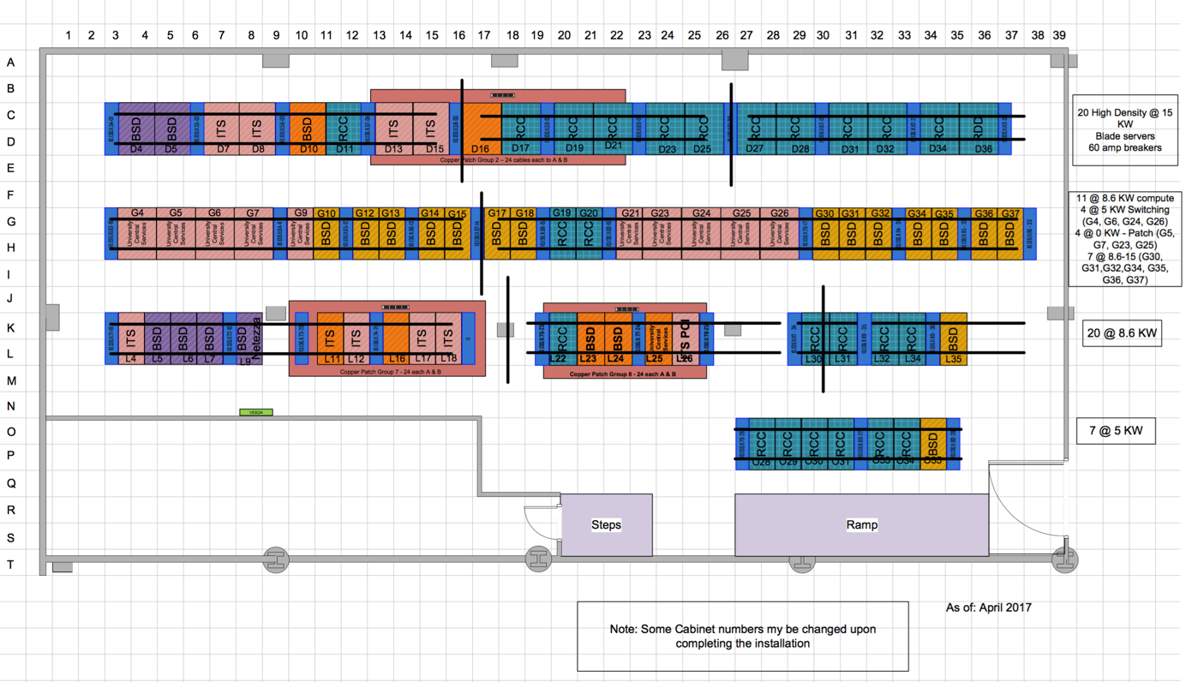
Pod-A floor layout

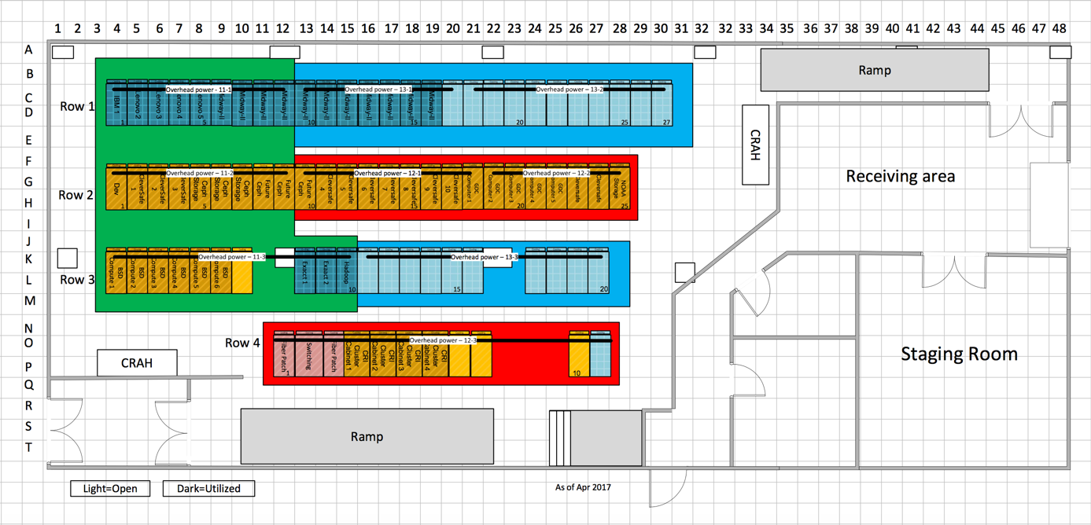
Pod-B floor layout

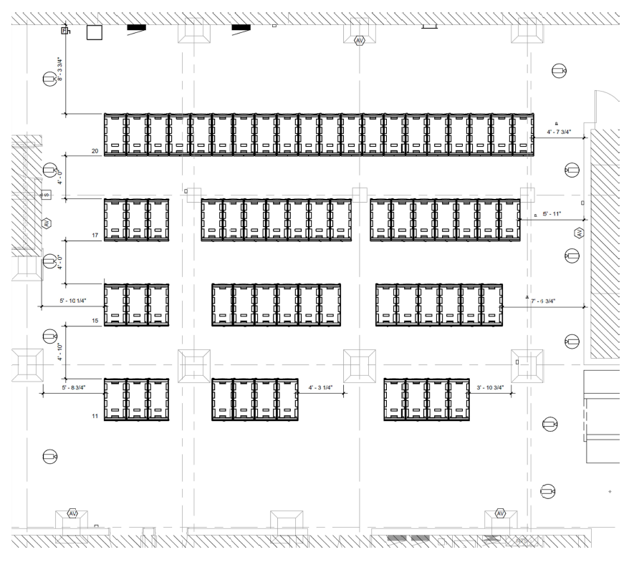
Pod-C floor layout

Cabinet general requirements
All cabinets to be 24” (600mm) wide x 48” (1200mm) (maximum, excluding heat exchanger) deep
All cabinets to be no taller than 42RU tall
Cabinet front doors will have adequate perforations supporting cooling via passive rear door heat exchangers
Maximum weight ratings of each cabinet not to exceed: 280 lbs./sq. ft. for POD-B and 500 lbs./sq. ft for POD-C
All cabinets to be weighed and details provide prior to shipment.
All cabinets will have actual weight clearly marked
Vendor is responsible to remove all packing material and trash.
Loaded equipment cabinets will be delivered directly to the computer floor
Cabinet power
All devices to accommodate 240/415 volt (no 110/208V will be supported)
All Cabinet Distribution Units (CDU’s) will be 3-Phase power distribution, 415 VAC
CDU input connectors will utilize two L22-30 -32 amp connections per cabinet
All CDU’s will, minimum, be “smart” providing SNMP access for monitoring total power, temperature, and humidity.
Outlet level monitoring and/or switched outlets are optional
If alternate amp or power connections are to be utilized, client will provide Starline busway TAP connection for non-standard electrical connections are required. Specifications will be provided by IT Services
Cabinet cooling
Each cabinet will be cooled by a passive, rear door heat exchanger.
Each heat exchanger will support:
Maximum GPM - 23
Minimum GPM - 3
Entering water temperature - 59F
Exiting water temperature (expected) - 66.5F
Chilled water pipe connection is 1” SAE thread
Maximum Pressure – 10 bar or 145 psi
Maximum water pressure drop – 20 ft.
Cabinets shall not introduce any additional heat load to the room.
Exhaust air must remain neutral or cooler than entering air.
Network
Network cabling will be mounted to the overhead cable management system

